DOMINO'S PIZZA
SENTIMENT, EMOTION
& BRAND PERCEPTION
ANALYSIS REPORT
What customers are saying, how they feel, why they feel that way, and what the company should do about it.
Brand Name | Domino's Pizza
Report Title | Sentiment, Emotion and Brand Perception Analysis
Period Covered | Reconstructed comment dates: 21 July 2020 - 20 July 2026; collection window: 21 July 2026, 10:00-20:00 WAT
Data Source | 130 manually collected social-media records; 129 usable comments across YouTube, Instagram, TikTok, Facebook and X/Twitter
Analyst Name | Peter Nnamdi Ileh
Date | 21 July 2026

REPORT STATUS
Executive-ready exploratory analysis. Because the sample is small and purposively collected, all findings should be interpreted as directional evidence rather than population-level measurement.

CONFIDENTIAL - CLASS ACTIVITY

REPORT CONTENTS
Section | Title | Purpose
2 | Executive Summary | Decision-level findings and priority implications
3 | Objectives | Business questions answered
4 | Dataset Overview | Scope, cleaning, date reconstruction and limitations
5 | Overall Sentiment Analysis | Positive, negative, neutral and mixed distribution
6 | Sentiment Trend Over Time | Directional historical pattern using reconstructed dates
7 | Emotion Analysis | Positive and negative emotional drivers
8 | Brand Perception Analysis | How customers describe and experience the brand
9 | Aspect-Based Sentiment Analysis | Sentiment by taste, price, service, delivery and other aspects
10 | Topic Analysis | Recurring themes ranked by frequency
11 | Entity Analysis | Products, locations, people and competitors
12 | Complaint Analysis | Operational failure categories
13 | Praise Analysis | What delights customers
14 | Opportunity Analysis | Growth, recovery and competitive opportunities
15 | Visualizations | Word cloud and geographic mention map
16 | Actionable Recommendations | Immediate, medium-term and long-term plan
17 | Conclusion | Overall perception and expected business impact
HOW TO READ THE RESULTS
Percentages use 129 usable comments. Emotion, aspect, complaint, praise and topic coding is multi-label, so those percentages and counts can overlap and do not sum to 100%.

2. Executive Summary
A directional but decision-useful view of the customer experience represented in the supplied sample.
51.9%  NEGATIVE | 26.4%  POSITIVE | 13.2%  NEUTRAL | 8.5%  MIXED

The sample presents a polarized Domino's brand. Customers continue to express strong love for specific pizzas, crusts, toppings, menu items and value deals. At the same time, the dominant operational story is inconsistency: customers report late or failed fulfilment, poor complaint handling, rude or unsafe staff behaviour, weak app and tracker performance, small portions, cold or poorly prepared food, and pricing that appears confusing or unfair.
Executive answer to the fundamental question
WHAT CUSTOMERS ARE SAYING
Domino's is frequently described as tasty, craveable, familiar and deal-friendly - but also inconsistent, deal-dependent, operationally unreliable and weak at service recovery.

HOW THEY FEEL
The most prevalent emotions are disappointment (48.8%), frustration (48.1%) and anger (31.0%). Positive energy remains material: joy and excitement each appear in 26.4% of comments, with hope in 22.5% and loyalty in 20.9%.

WHY THEY FEEL THAT WAY
Positive feelings are driven by taste, favourite products, crust and topping preferences, perceived deals, and long-standing brand familiarity. Negative feelings are driven by inconsistent food quality, unresolved complaints, missed or wrong orders, long waits, delivery problems, staff conduct, price-value concerns and digital failures.

WHAT THE COMPANY SHOULD DO
Protect the taste and loyalty advantage while urgently standardising execution. The highest-priority actions are a service-recovery SLA, high-risk complaint escalation, store-level quality and fulfilment audits, staff/driver standards, and app/tracker reliability fixes.

Six decision-level findings
1. Negative experience dominates the sample. 67 of 129 usable comments are negative. A further 11 are mixed, meaning criticism appears in more than half of the usable dataset.
2. The problem is execution, not absence of brand affection. Taste and flavour generated 34 praise mentions, while brand love and loyalty generated 32. The brand still has emotional equity to protect.
3. Service recovery is a major trust gap. Customer service and recovery was mentioned 32 times; 29 mentions were negative. Customers repeatedly describe unanswered calls, delayed refunds and unresolved cases.
4. Fulfilment failures are highly visible. Waiting time had 24 mentions and all were negative. Order accuracy and fulfilment had 26 mentions, of which 25 were negative.
5. Platform differences largely reflect sampling context. Facebook is 89.5% negative and Instagram 77.4% negative, while YouTube and TikTok are more positive. The Facebook source is explicitly complaint-focused, so this is not a platform-wide market estimate.
6. Menu demand is both nostalgic and progressive. Customers ask for discontinued favourites such as pasta, Brooklyn style, Buffalo Chicken Pizza, brownies and bread bowls, while repeated vegan-cheese requests signal an inclusion and market-expansion opportunity.
Representative voice of the customer
“Dominos is comfortably the best chain pizza.”
Comment 76 | TikTok | Positive
“My orders have always been spot on and fresh... they have literally nailed it every time.”
Comment 23 | YouTube | Positive
“I can't get anywhere with customer service or anybody at any location.”
Comment 52 | Instagram | Negative
“Other than that, you guys have the best pizza! Thank you for all your hard work.”
Comment 108 | Facebook | Mixed

3. Objectives
This analysis was designed to answer the executive question: “What are customers saying, how do they feel, why do they feel that way, and what should the company do about it?”
- Quantify overall positive, negative, neutral and mixed sentiment.
- Identify the emotions behind customer reactions, including loyalty, excitement, disappointment, anger and frustration.
- Determine which business aspects drive positive and negative sentiment.
- Extract recurring topics, complaints, praise themes, products, locations, people and competitor references.
- Describe the brand perceptions communicated by the comments.
- Identify operational, marketing, product and digital opportunities.
- Prioritise practical recommendations across 0-30 days, 1-6 months and 6-12 months.
- Provide a transparent audit trail in the accompanying analysis workbook.
DECISION USE
The report is most useful as a structured diagnostic and hypothesis generator. It should guide investigation, prioritisation and larger-scale measurement - not be treated as a statistically representative brand-health tracker.

4. Dataset Overview
Observed file contents, cleaning decisions and reconstruction assumptions.
Dataset Attribute | Value
Numbered records | 130
Usable comment texts | 129
Blank records excluded | 1 (ID 99)
Continuation rows merged | 5
Observed platforms | YouTube, Instagram, TikTok, Facebook and X/Twitter
Collection date/time | 21 July 2026, 10:00-20:00 WAT
Nominal reconstructed comment span | 21 July 2020 - 20 July 2026
Analyst | Peter Nnamdi Ileh
Platform composition and sentiment
Platform | Usable | Positive | Negative | Neutral n | Mixed n
YouTube | 30 | 46.7% | 23.3% | 5 | 4
Instagram | 31 | 16.1% | 77.4% | 1 | 1
TikTok | 30 | 40.0% | 30.0% | 6 | 3
Facebook | 19 | 0.0% | 89.5% | 0 | 2
X (Twitter) | 19 | 15.8% | 52.6% | 5 | 1
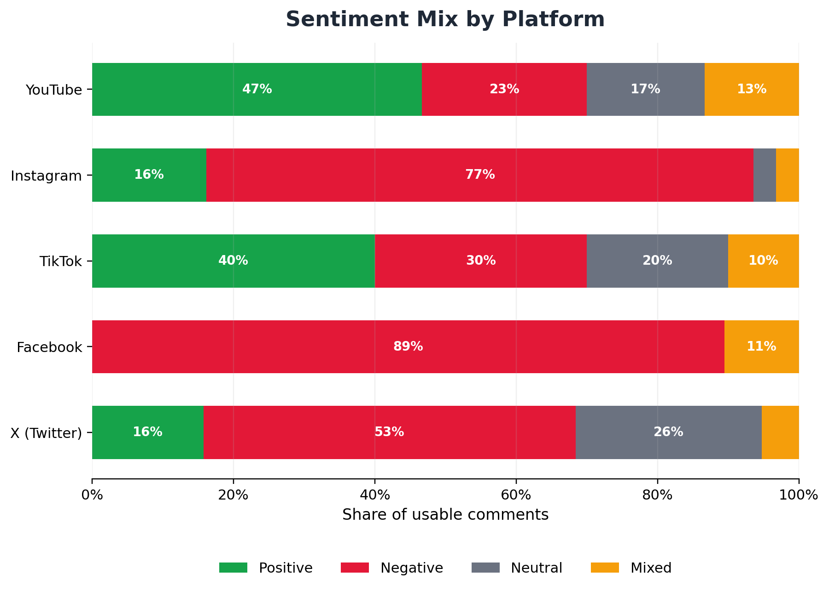
Figure 1. Platform-level sentiment mix. Interpret differences as sample composition, not population-level platform performance.
Data cleaning and date reconstruction
- Five unnumbered continuation rows were joined to the preceding numbered comment so that multi-line comments remained one analytical record.
- IDs 129 and 130 had blank platform cells but shared the same post title and date context as the preceding X/Twitter records; they were coded as X/Twitter.
- ID 99 had no comment text and was excluded from sentiment, emotion, aspect and topic percentages.
- Excel date serials were converted to calendar dates and treated as exact dates.
- Relative labels such as “three weeks ago,” “seven months ago” and “six years ago” were anchored to 21 July 2026 at 20:00 WAT. These are nominal approximations because platforms round relative timestamps.
- Missing post or comment dates were retained as missing rather than imputed.
Date precision profile
Precision Type | Records
Comment date - exact serial | 61
Comment date - week approximation | 32
Comment date - year approximation | 23
Comment date - month approximation | 7
Comment date - day approximation | 5
Comment date - missing | 2
Material limitations
- Small sample: 129 usable comments cannot estimate the sentiment of Domino’s total customer base.
- Purposive collection: comments were manually selected rather than randomly sampled.
- Post-context bias: some comments react to creators or marketing posts rather than direct customer experiences.
- Complaint-source bias: the Facebook source title is explicitly complaint-focused, strongly increasing negative prevalence.
- Historical mixing: comments span reconstructed years and markets, so they do not represent one operating period or geography.
- No engagement weighting: likes, replies, reach, follower count and verified purchase status were unavailable.
- Sarcasm and ambiguity were human-reviewed, but interpretation remains judgement-based.
- Competitor and location findings use only explicit mentions inside the dataset.
INTERPRETATION RULE
Use counts to identify recurring signals and operational hypotheses. Do not use the percentages as audited estimates of Domino’s global customer sentiment.

5. Overall Sentiment Analysis
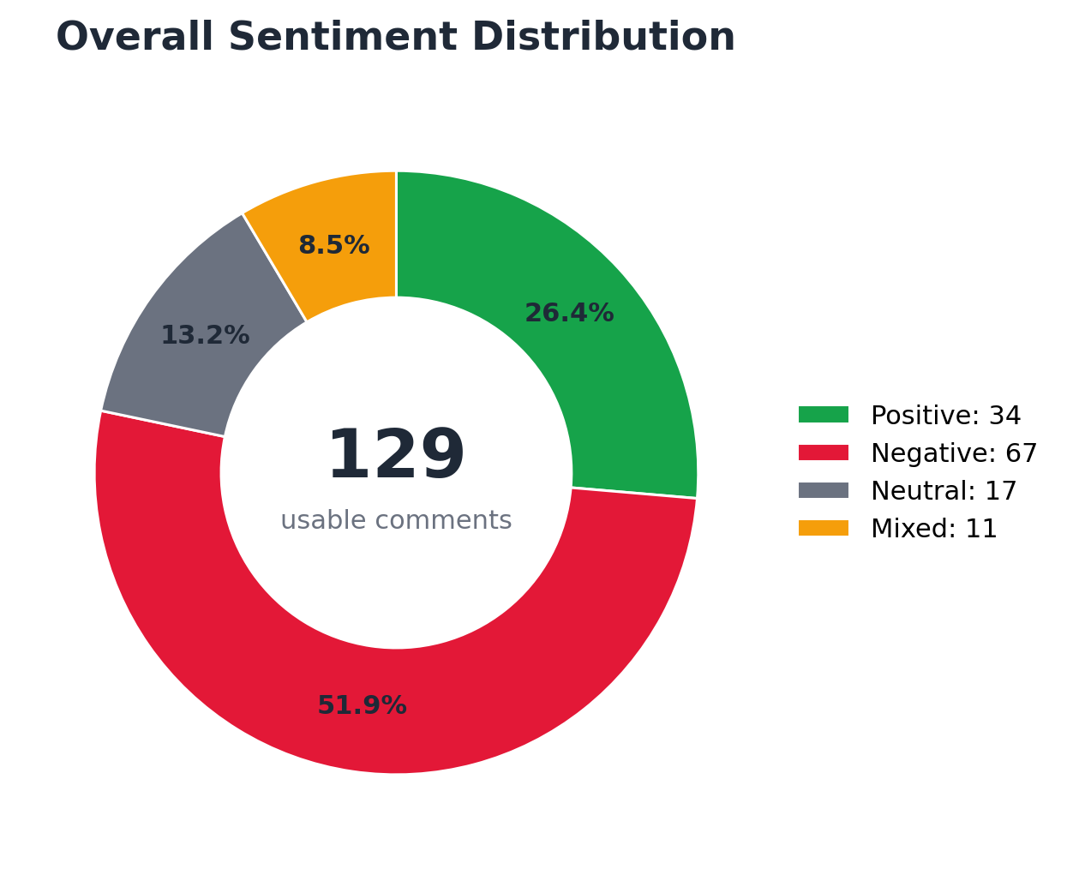
Figure 2. Overall sentiment distribution across 129 usable comments.
Sentiment | Count | Share | Interpretation
Positive | 34 | 26.4% | Clear praise, affection, satisfaction or favourable recommendation.
Negative | 67 | 51.9% | Clear criticism, complaint, rejection, anger or dissatisfaction.
Neutral | 17 | 13.2% | Information, questions, humour or comments without a clear brand evaluation.
Mixed | 11 | 8.5% | Meaningful praise and criticism in the same comment.
Interpretation
Negative comments are the majority at 51.9%. When the 8.5% mixed category is added, 60.5% of usable comments contain at least some meaningful criticism. This signals an operational and trust-recovery issue within the sampled conversations.
Positive sentiment remains substantial at 26.4%. It is concentrated around taste, favourite products, crusts, toppings, promotions and long-term brand affection. This matters strategically: Domino’s is not rebuilding from zero brand equity; it is trying to close the gap between a desirable product promise and inconsistent execution.
CORE SENTIMENT TENSION
Customers often want to love Domino’s, but repeated execution failures create disappointment precisely because expectations and prior loyalty are high.

6. Sentiment Trend Over Time
A directional historical view using reconstructed comment dates.
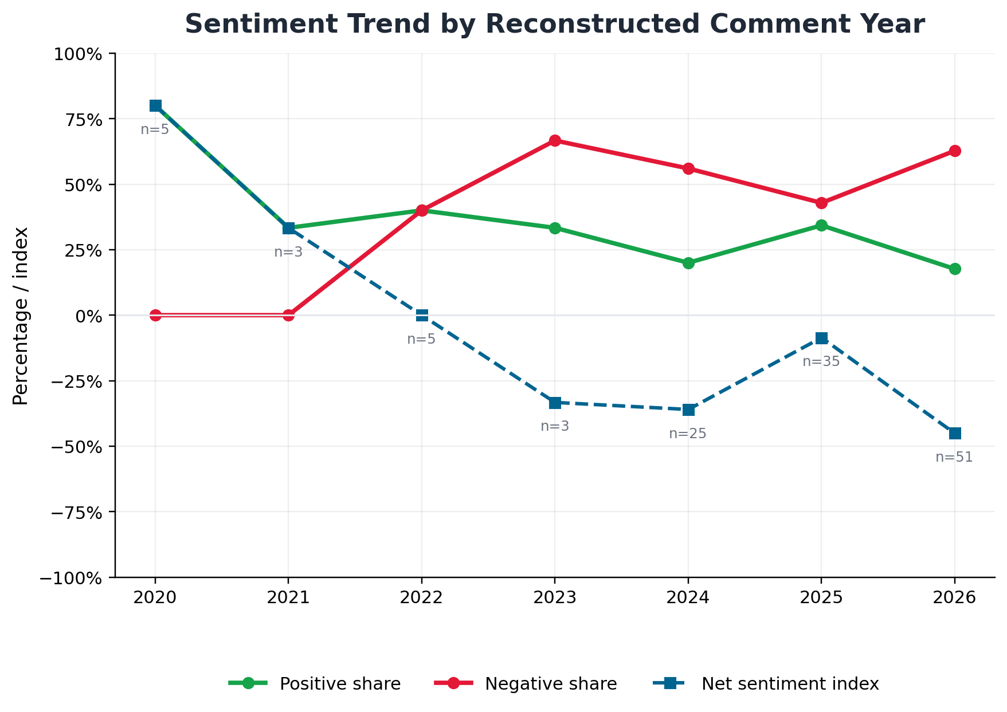
Figure 3. Positive share, negative share and net sentiment index by reconstructed comment year. Annual sample sizes are shown on the chart.
Year | n | Positive | Negative | Neutral | Mixed | Net Index
2020 | 5 | 4 | 0 | 1 | 0 | +80.0
2021 | 3 | 1 | 0 | 0 | 2 | +33.3
2022 | 5 | 2 | 2 | 1 | 0 | +0.0
2023 | 3 | 1 | 2 | 0 | 0 | -33.3
2024 | 25 | 5 | 14 | 4 | 2 | -36.0
2025 | 35 | 12 | 15 | 6 | 2 | -8.6
2026 | 51 | 9 | 32 | 5 | 5 | -45.1
The sampled comments become more negative in the later reconstructed years, with a net sentiment index of -45.1 in 2026. This should not be read as a validated deterioration trend because the sample composition changes over time and recent records are disproportionately drawn from complaint-heavy Facebook and X/Twitter sources.
MANAGEMENT USE
Treat the temporal pattern as a warning signal worth validating with a larger, continuously collected and stratified dataset. It is not sufficient evidence, by itself, to claim that global brand sentiment has worsened over time.

7. Emotion Analysis
Multi-label emotion coding: one comment can express several emotions.
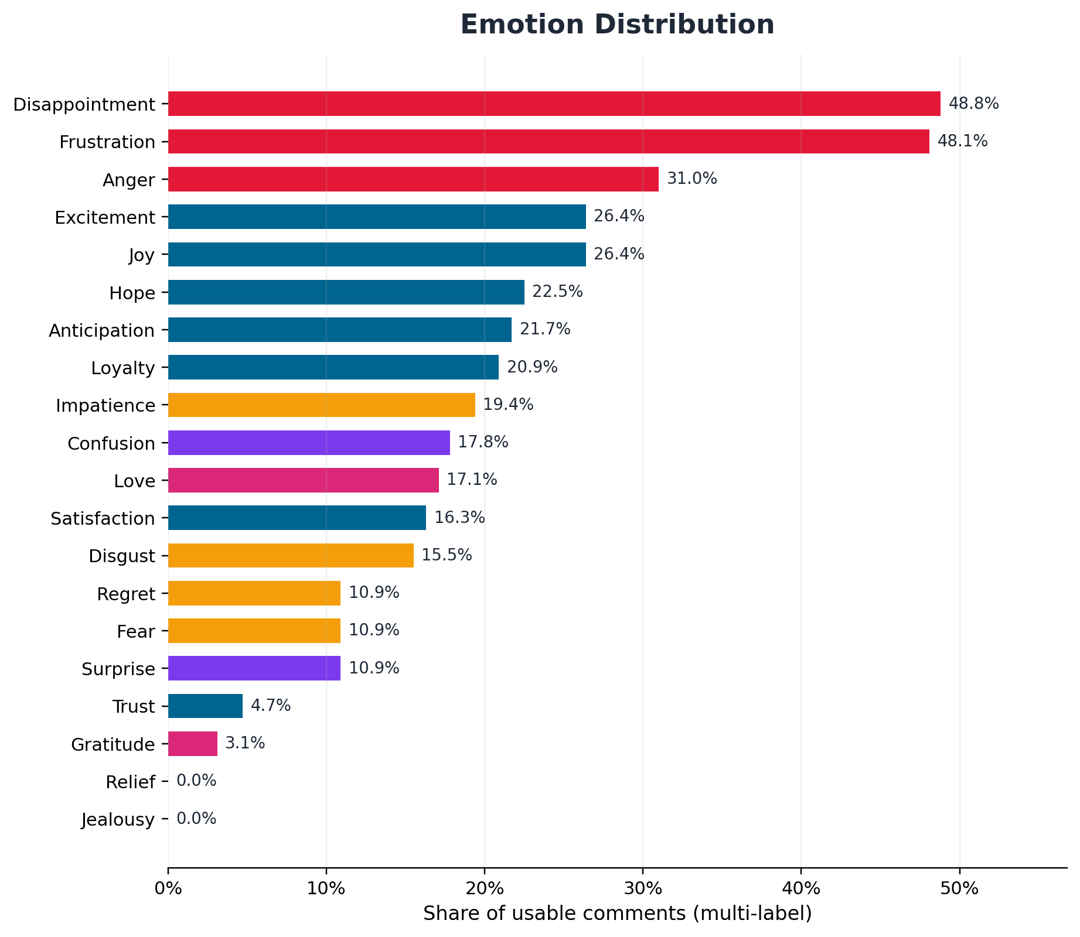
Figure 4. Emotion prevalence as a percentage of 129 usable comments. Percentages overlap and therefore exceed 100% in total.
Emotion | n | Share | Emotion | n | Share
Disappointment | 63 | 48.8% | Love | 22 | 17.1%
Frustration | 62 | 48.1% | Satisfaction | 21 | 16.3%
Anger | 40 | 31.0% | Disgust | 20 | 15.5%
Joy | 34 | 26.4% | Surprise | 14 | 10.9%
Excitement | 34 | 26.4% | Fear | 14 | 10.9%
Hope | 29 | 22.5% | Regret | 14 | 10.9%
Anticipation | 28 | 21.7% | Trust | 6 | 4.7%
Loyalty | 27 | 20.9% | Gratitude | 4 | 3.1%
Impatience | 25 | 19.4% | Jealousy | 0 | 0.0%
Confusion | 23 | 17.8% | Relief | 0 | 0.0%
Emotional interpretation
DISAPPOINTMENT AND FRUSTRATION ARE THE CENTRAL RISK.
These emotions reflect expectation failure: customers expected a familiar national chain to deliver basic consistency, responsiveness and reliability.

ANGER ESCALATES WHEN RECOVERY FAILS.
Anger is particularly associated with unanswered calls, refunds, threats, perceived discrimination, unsafe driving, misleading tracker information and repeated failures.

JOY AND EXCITEMENT SHOW THE PRODUCT STILL CREATES DESIRE.
Positive emotion is driven by specific flavours, crusts, toppings, menu discoveries, visual appeal and cravings.

HOPE AND ANTICIPATION INDICATE CUSTOMERS STILL INVITE IMPROVEMENT.
Requests for vegan cheese, discontinued products, more cheese, menu innovation and market return show that many customers have not emotionally disengaged.

LOYALTY IS BOTH AN ASSET AND A CHURN WARNING.
Long-term customers describe go-to products and years of membership, but some also say they are done supporting the brand after repeated failures.

Jealousy and relief were not materially observed in the supplied comments. Their 0% result should be interpreted as absence from this small sample, not proof that these emotions never occur in the wider customer base.

8. Brand Perception Analysis
How customers describe Domino’s and what those descriptions imply.
Perception | Evidence in Customer Language | Business Meaning
Craveable and product-led | Taste, crust, cheese, toppings and named menu items create excitement and repeat-purchase intent. | Strength to protect
Familiar and emotionally embedded | Customers use language such as “go-to,” “love,” “favourite,” “die hard fan” and long-term rewards membership. | Loyalty asset
Deal-dependent rather than transparently priced | Several comments imply that full price is unrealistic, offers are confusing, or fees cancel the benefit of promotions. | Value perception risk
Inconsistent across stores and occasions | Positive product experiences coexist with burnt, cold, smelly, under-topped, small or poorly presented orders. | Operational consistency risk
Digitally convenient in promise, unreliable in execution | The app, payment flow, rewards, free-pizza links and tracker generate frustration when they fail or display inaccurate status. | Digital trust gap
Weak at complaint recovery | Customers report unanswered calls, delayed refunds, no response to cases and staff indifference. | Trust and churn risk
Menu with strong nostalgia and innovation potential | Customers request discontinued favourites while also asking for vegan cheese and localised flavours. | Growth opportunity
Polarising, not irrelevant | The brand attracts intense love and intense anger. Strong emotional reaction indicates salience, but negative salience can damage advocacy. | Brand equity at risk
Brand perception statement
SYNTHESIS
In this sample, Domino's is perceived as a highly familiar, craveable and promotion-oriented pizza brand whose strongest weakness is not product awareness but inconsistent delivery of the promise across food preparation, fulfilment, people, pricing and digital channels.

Competitive benchmarking within the sample
Competitor / Alternative | Mentions | Interpretation
Local / independent outlets | 5 comments | Local alternatives are treated as credible substitutes; one Lagos comment actively asks for better pizza places.
Pizza Hut | 2 comments | Referenced in the context of UK deal pricing and a warning that poor service can lead to store closure.
Papa Johns | 2 comments | Referenced in UK discount culture and a pan-pizza comparison.
Marcos | 1 comment | An explicit switching intention caused by poor portion-value perception.
Unnamed chain competitors | 1 comment | A customer calls Domino’s “comfortably the best chain pizza.”
Only 10 unique comments contain a meaningful competitor or alternative reference, so the benchmark is qualitative. The evidence suggests Domino’s competitive advantage is taste, crust and brand familiarity, while switching risk is triggered by poor value and inconsistent execution.
9. Aspect-Based Sentiment Analysis
Sentiment is assessed separately for each business aspect mentioned in a comment.
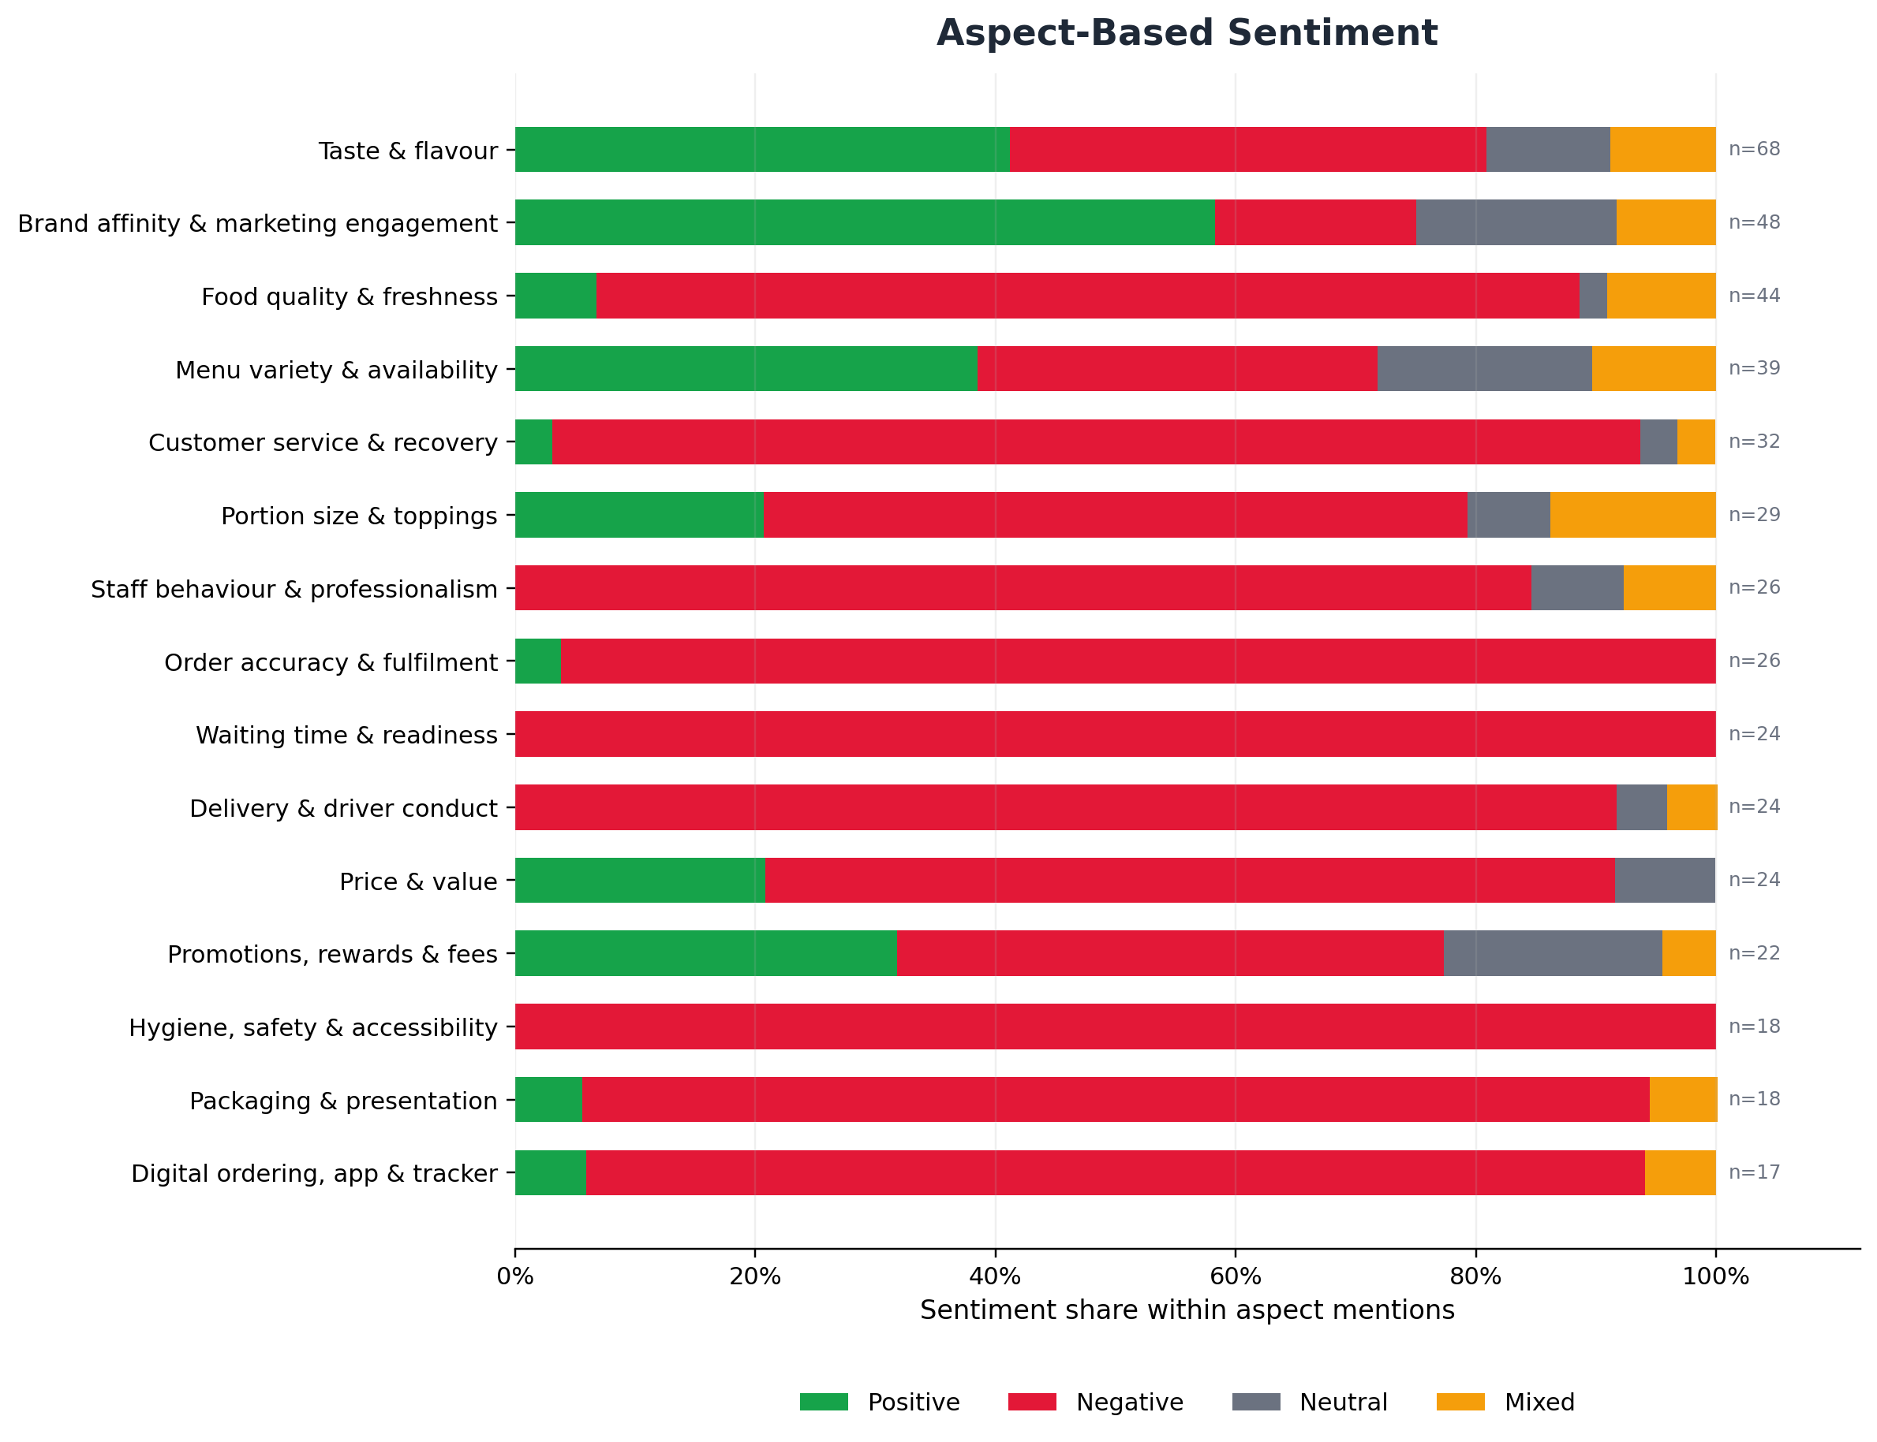
Figure 5. Sentiment distribution within each aspect. The n-value indicates the number of comments that mention the aspect.
Aspect | n | Positive | Negative | Executive Interpretation
Taste & flavour | 68 | 41% | 40% | Polarised: major praise driver and major quality risk.
Brand affinity & marketing engagement | 48 | 58% | 17% | Strong positive equity and engagement potential.
Food quality & freshness | 44 | 7% | 82% | Critical consistency gap.
Menu variety & availability | 39 | 38% | 33% | Mixed demand: favourites, innovation and discontinuation pain.
Customer service & recovery | 32 | 3% | 91% | Severe trust and recovery weakness.
Portion size & toppings | 29 | 21% | 59% | Requires store-level standardisation and monitoring.
Order accuracy & fulfilment | 26 | 4% | 96% | Near-uniform failure perception.
Staff behaviour & professionalism | 26 | 0% | 85% | Requires store-level standardisation and monitoring.
Price & value | 24 | 21% | 71% | Deals help, but value and fee concerns dominate.
Delivery & driver conduct | 24 | 0% | 92% | Requires store-level standardisation and monitoring.
Waiting time & readiness | 24 | 0% | 100% | Uniformly negative in this sample.
Promotions, rewards & fees | 22 | 32% | 46% | Requires store-level standardisation and monitoring.
Packaging & presentation | 18 | 6% | 89% | Requires store-level standardisation and monitoring.
Hygiene, safety & accessibility | 18 | 0% | 100% | High-risk compliance and reputation issue.
Digital ordering, app & tracker | 17 | 6% | 88% | Reliability gap undermines convenience promise.
Highest-priority aspect findings
- Waiting time and readiness: 24 mentions, all negative. Customers describe inaccurate estimates, orders sitting in “quality check,” and orders not being prepared when promised.
- Order accuracy and fulfilment: 26 mentions, 25 negative. Wrong, missing, undelivered or under-topped orders are a core operational failure theme.
- Customer service and recovery: 32 mentions, 29 negative. The brand’s response after a failure often appears to intensify the original complaint.
- Hygiene, safety and accessibility: 18 mentions, all negative. Reports include glass, unpleasant smells, illness concerns, glove requests, unsafe driving, threats, discrimination and service-dog denial.
- Taste and flavour: 68 mentions with 28 positive, 27 negative and 6 mixed. Product appeal is powerful but inconsistent.

10. Topic Analysis
Recurring discussion themes ranked by frequency. A comment can contribute to multiple topics.
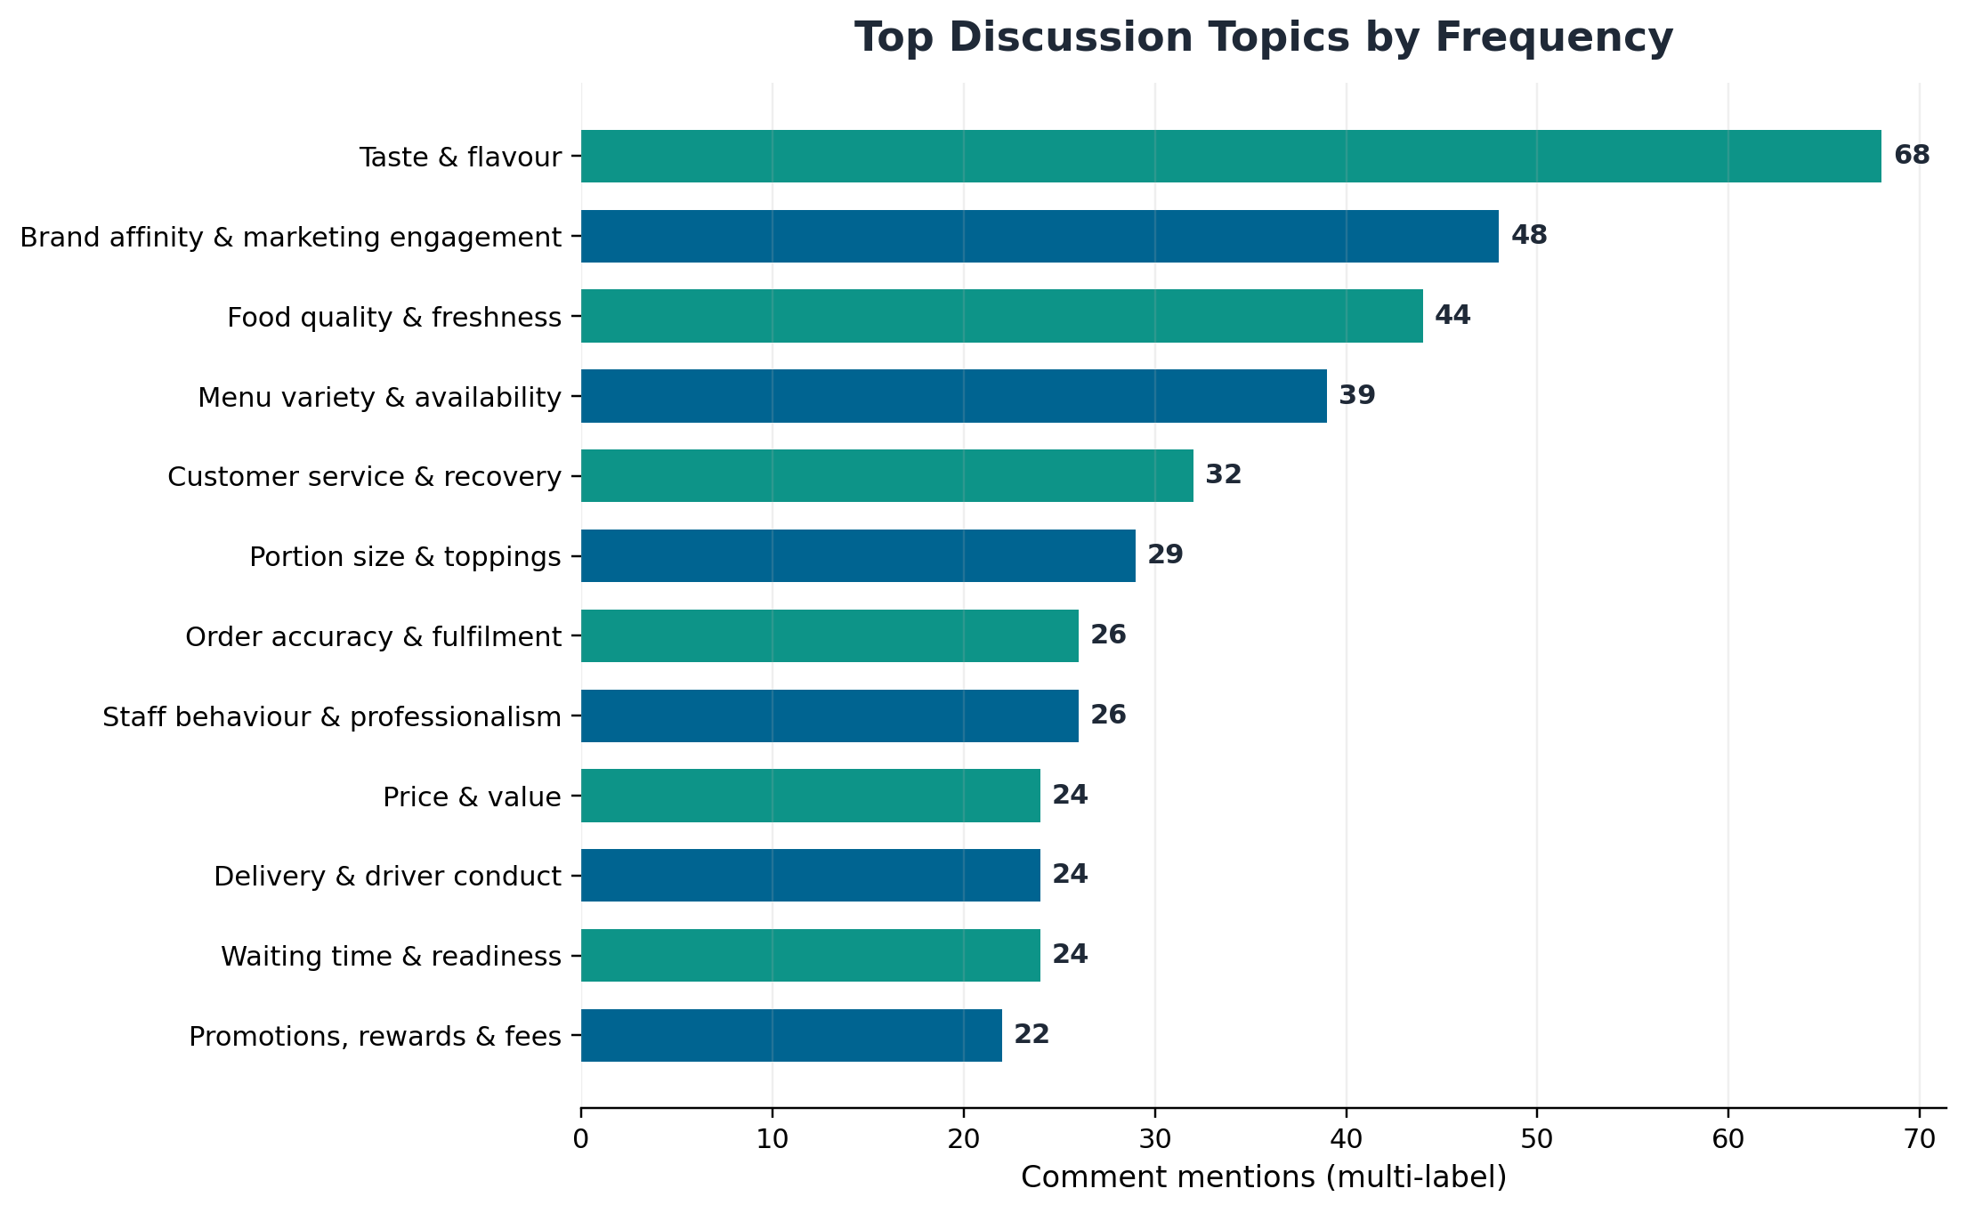
Figure 6. Top recurring topics by number of comment mentions.
Rank | Topic | Mentions | Share of Comments
1 | Taste & flavour | 68 | 52.7%
2 | Brand affinity & marketing engagement | 48 | 37.2%
3 | Food quality & freshness | 44 | 34.1%
4 | Menu variety & availability | 39 | 30.2%
5 | Customer service & recovery | 32 | 24.8%
6 | Portion size & toppings | 29 | 22.5%
7 | Order accuracy & fulfilment | 26 | 20.2%
8 | Staff behaviour & professionalism | 26 | 20.2%
9 | Price & value | 24 | 18.6%
10 | Delivery & driver conduct | 24 | 18.6%
11 | Waiting time & readiness | 24 | 18.6%
12 | Promotions, rewards & fees | 22 | 17.1%
The topic structure confirms that customer discussion is product-led but operationally constrained. Taste and brand affinity generate the largest conversation volume, while food quality, customer service, fulfilment, staff behaviour, delivery, waiting and price concerns dominate the risk agenda.
TOPIC IMPLICATION
Marketing can continue to use flavour, cravings and product fandom to create demand, but operations and customer experience must prevent those campaigns from generating disappointment when stores cannot consistently fulfil the promise.

11. Entity Analysis (Named Entity Recognition)
Manually reviewed extraction of products, locations, people and competitor references.
Top product and menu entities
Product / Menu Entity | Mentions | Comment IDs
Vegan / dairy-free cheese | 5 | 35, 41, 45, 46, 122
Emergency Pizza | 4 | 124, 125, 126, 127
Garlic bread / bites | 4 | 19, 31, 40, 96
Pasta / Italian Sausage Marinara | 4 | 18, 28, 36, 37
Thin crust | 4 | 6, 9, 10, 11
Brooklyn crust/style | 3 | 10, 53, 54
Sandwiches | 2 | 18, 104
Alfredo pizza | 1 | 81
Bread bowl | 1 | 129
Brownies | 1 | 61
Buffalo Chicken Pizza | 1 | 38
Cheese Burst | 1 | 19
Location entities
Location Entity | Mentions | Comment IDs
India | 7 | 19, 20, 25, 29, 30, 31, 40
United Kingdom | 5 | 14, 15, 16, 17, 21
Canada / Ontario | 2 | 12, 43
Lagos, Nigeria | 2 | 64, 65
Atlanta, Georgia | 1 | 36
Cambridge / KWC, Ontario | 1 | 43
Carrollton / New Orleans, Louisiana | 1 | 108
Chicago, Illinois | 1 | 13
Columbia, Maryland | 1 | 96
Cranston, Rhode Island | 1 | 104
Detroit, Michigan | 1 | 49
Doral, Florida | 1 | 44
Kishangarh (spelled Krishangarh) | 1 | 31
Maurice, Louisiana | 1 | 95
Noida | 1 | 30
Pittsfield, Massachusetts | 1 | 101
Plainview, Texas | 1 | 107
South Africa (SA) | 1 | 89
Thiruvanmiyur / Chennai | 1 | 25
Wheatland / Duncanville, Texas | 1 | 50
People and role entities
Named Person | Mentions | Comment IDs
Polar (content creator nickname) | 2 | 2, 4
Lewis | 1 | 1
Joe | 1 | 18
Rebecca Manning | 1 | 50
Most employee references are role-based rather than personally named: manager, assistant manager, driver, rider, delivery executive, employee and store staff. This means the strongest actionable entity is usually the store location or role category, not a specific individual.
ENTITY GOVERNANCE
Names, case IDs, order references and public allegations in raw comments are unverified. They should be routed into a controlled investigation process and not treated as confirmed facts without operational validation.

12. Complaint Analysis
Complaint categories are multi-label because one experience can contain several failures.
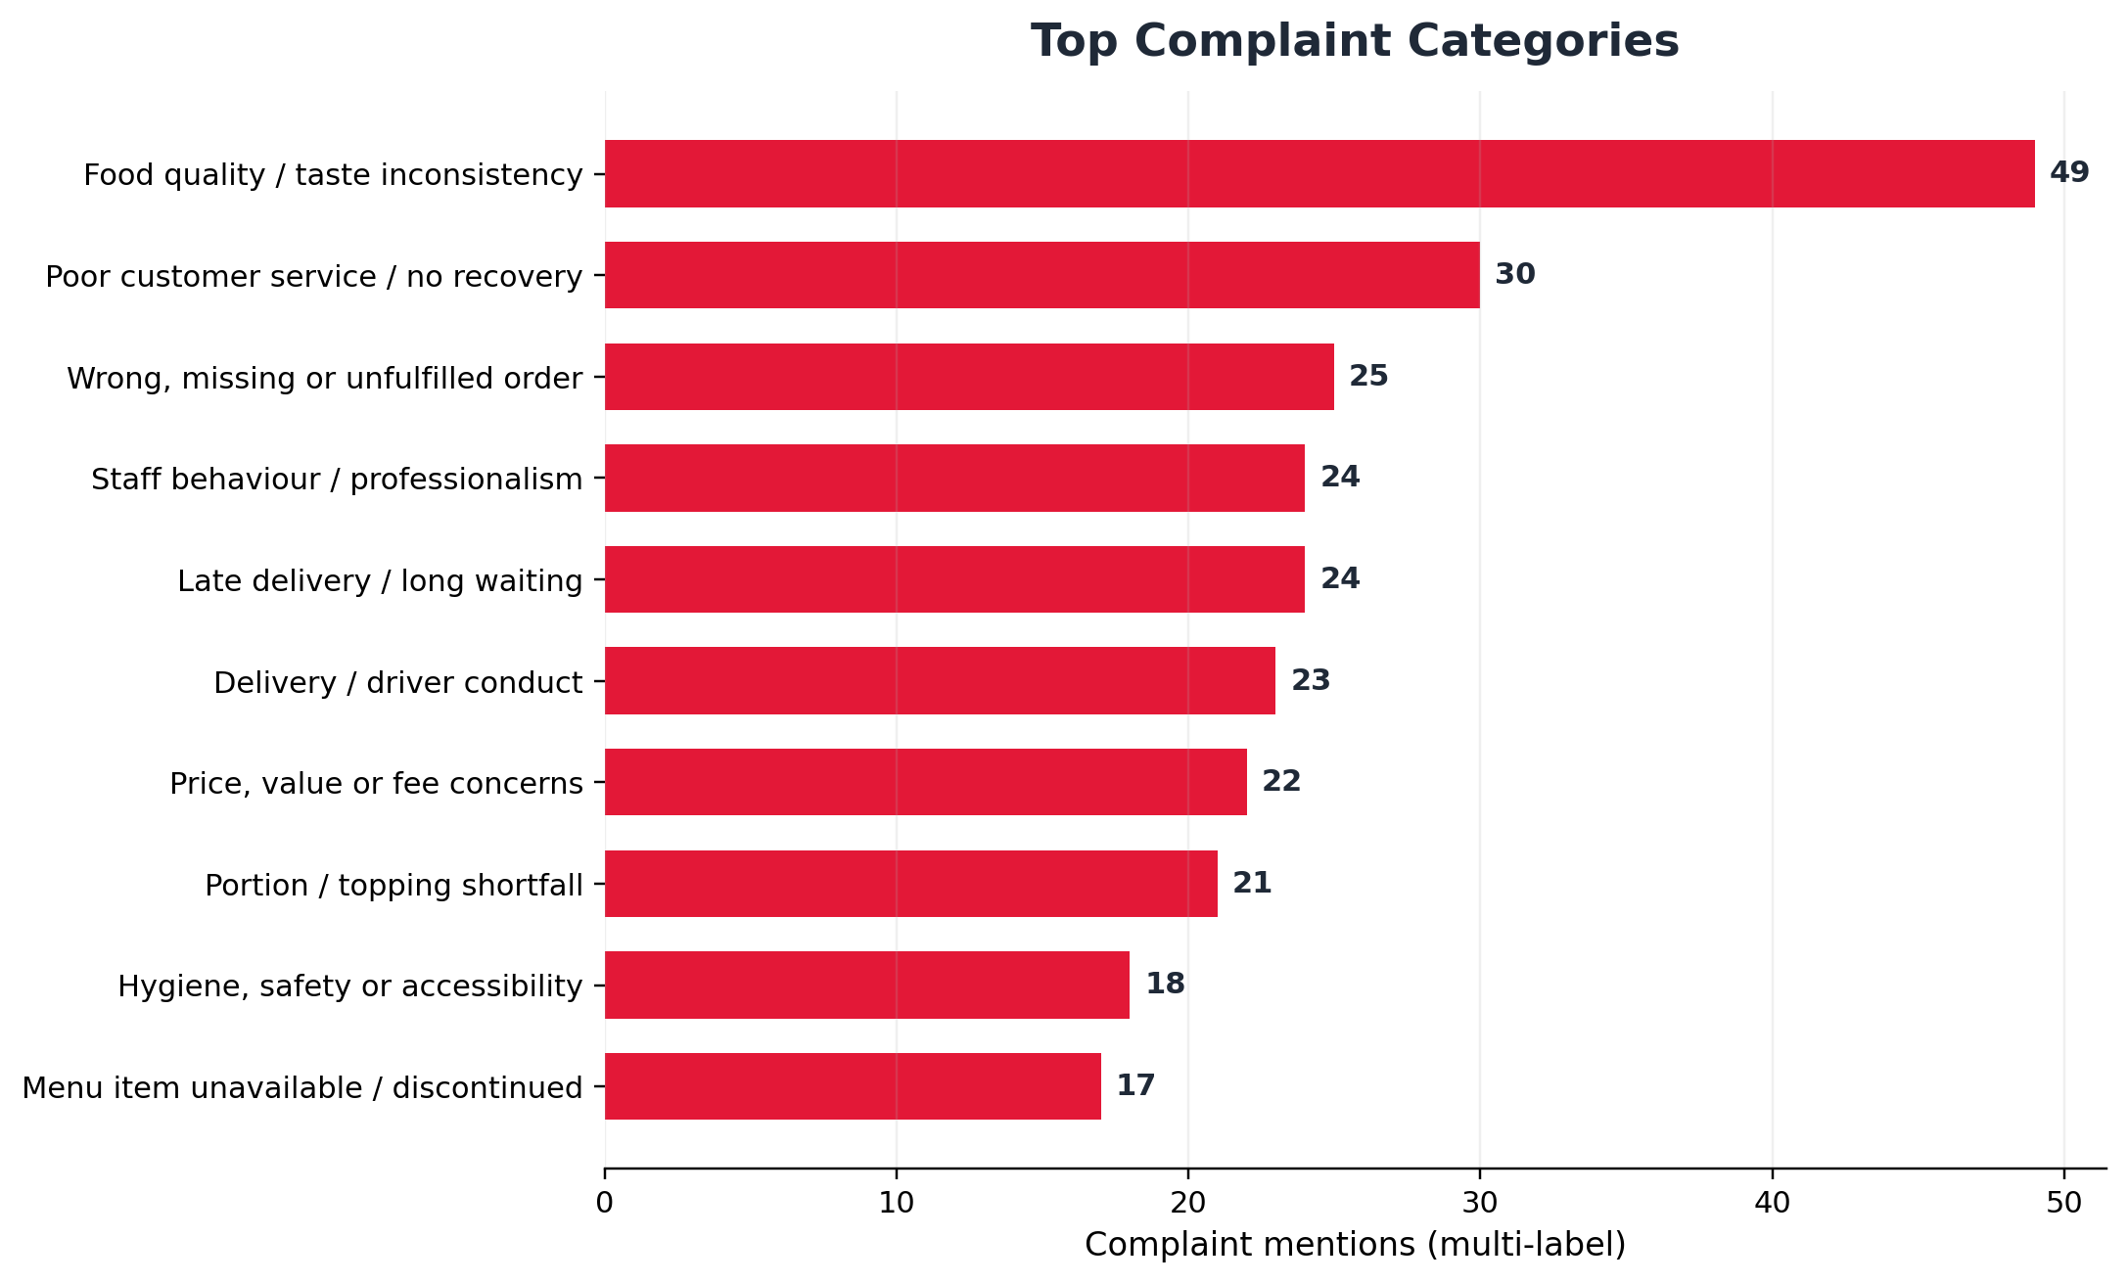
Figure 7. Most frequent complaint categories in the supplied sample.
Rank | Complaint Category | Mentions | Share
1 | Food quality / taste inconsistency | 49 | 38.0%
2 | Poor customer service / no recovery | 30 | 23.3%
3 | Wrong, missing or unfulfilled order | 25 | 19.4%
4 | Staff behaviour / professionalism | 24 | 18.6%
5 | Late delivery / long waiting | 24 | 18.6%
6 | Delivery / driver conduct | 23 | 17.8%
7 | Price, value or fee concerns | 22 | 17.1%
8 | Portion / topping shortfall | 21 | 16.3%
9 | Hygiene, safety or accessibility | 18 | 14.0%
10 | Menu item unavailable / discontinued | 17 | 13.2%
11 | Packaging / presentation | 17 | 13.2%
12 | Digital ordering / payment / tracker | 16 | 12.4%
Complaint escalation levels
Severity | Examples | Required Response
Level 1 - Immediate safety/compliance | Glass or chemical concerns, illness, threats, unsafe driving, discrimination, service-dog denial, harassment or accessibility concerns. | Acknowledge immediately; preserve evidence; escalate to Legal/Compliance and Franchise Operations.
Level 2 - Transaction and fulfilment | Non-delivery, wrong or missing orders, cold food, payment/refund failures and severe delays. | Resolve with refund/remake and verified follow-up within a defined SLA.
Level 3 - Experience and value | Portion, toppings, pricing, fees, packaging, menu availability and routine service complaints. | Recover the customer, code the root cause and feed store/product dashboards.
“I ordered a pizza earlier this evening at 6:47. My last estimate of delivery is 10:30.”
Comment 100 | Facebook | Late delivery
“This is the tiniest Chicken Bacon Ranch sandwich I’ve ever seen... for almost $20.”
Comment 104 | Facebook | Portion/value
“Your app really sucks... a dialogue comes up stating that they are having technical difficulties.”
Comment 102 | Facebook | Digital ordering
13. Praise Analysis
What delights customers and should be protected or amplified.
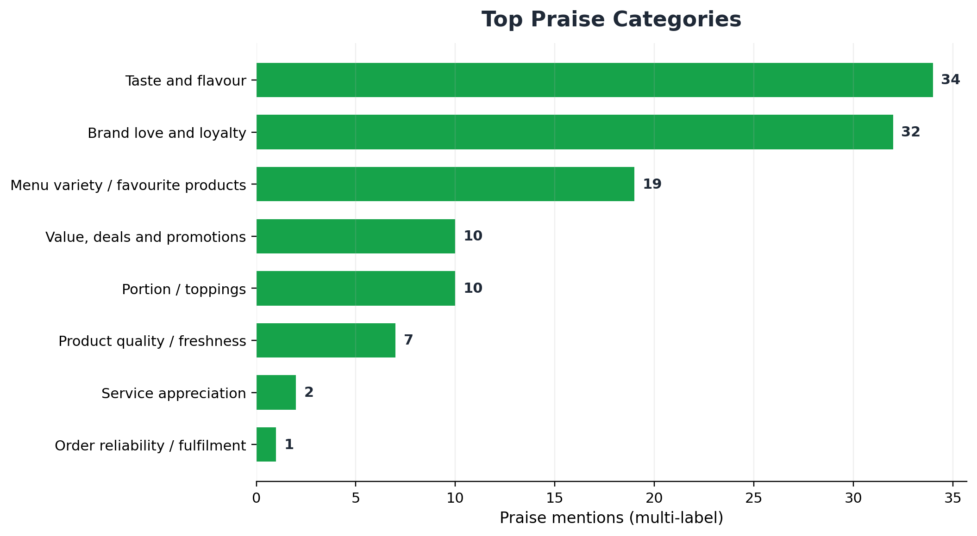
Figure 8. Most frequent praise categories in the supplied sample.
Rank | Praise Category | Mentions | Share
1 | Taste and flavour | 34 | 26.4%
2 | Brand love and loyalty | 32 | 24.8%
3 | Menu variety / favourite products | 19 | 14.7%
4 | Value, deals and promotions | 10 | 7.8%
5 | Portion / toppings | 10 | 7.8%
6 | Product quality / freshness | 7 | 5.4%
7 | Service appreciation | 2 | 1.6%
8 | Order reliability / fulfilment | 1 | 0.8%
What creates delight
- Specific flavours and products: oregano seasoning, jalapeño bread, Alfredo pizza, Texas BBQ, Parmesan Bites, hand-tossed crust, pan pizza and named toppings.
- Crust and texture preferences: thin crust, Brooklyn style and hand-tossed crust create distinct product identities.
- Cravings and visual appeal: content prompts immediate desire to order and strong anticipation.
- Deals and customisation: voucher codes, extra sauce and bundle pricing support value and convenience.
- Reliability when it works: customers praise orders that are fresh, accurate and consistently ready for events.
- Long-term affinity: “go-to,” “die hard fan,” “best chain pizza” and multi-year rewards membership reveal advocacy potential.
“Your pizza is so delicious! This former beauty queen loves your pizza.”
Comment 58 | Instagram | Taste/love
“Bro idk why so many people hate on dominos! I’m a die hard fan!”
Comment 83 | TikTok | Loyalty
PRAISE-TO-GROWTH LINK
Domino’s should use product fandom as a growth engine: build campaigns around specific menu heroes, customer customisation combinations, cravings and loyalty stories - while operational teams verify that featured items can be delivered consistently.

14. Opportunity Analysis
Opportunities are ranked by evidence volume, business risk and strategic upside.
Rank | Opportunity | Evidence | Priority | Why It Matters
1 | Food quality and portion consistency | 30 | Critical | Repeated concerns about taste deterioration, cold/burnt/smelly food, cheese/topping shortfalls and inconsistent sizing.
2 | Service recovery and complaint-resolution SLA | 11 | Critical | Refund delays, unanswered calls, unresolved cases and customers reporting that staff did not care.
3 | Delivery ETA, readiness and fulfilment reliability | 11 | Critical | Late delivery, quality-check delays, wrong addresses, unprepared orders and non-delivery.
4 | Staff, driver, hygiene and accessibility standards | 11 | High | Rudeness, threats, unsafe driving, glove concerns, service-dog denial and discrimination allegations.
5 | Pricing, fee and promotion simplification | 8 | High | Customers describe base pricing as confusing or meaningless and perceive fees as negating promotions.
6 | Digital app, payment, tracker and rewards reliability | 6 | High | Technical failures, misleading tracker status, payment errors and missing rewards/free-pizza benefits.
7 | Restore high-affinity discontinued products | 7 | Medium | Requests for pasta, Buffalo Chicken Pizza, Brooklyn style, brownies and bread bowls show nostalgia-led demand.
8 | Pilot vegan/dairy-free cheese | 5 | Medium | Repeated unmet demand framed around inclusion, health, environment and market growth.
9 | Localised menu innovation and customisation | 12 | Medium | Enthusiasm for paneer, oregano, Texas BBQ, Alfredo, jalapeños and topping customisation.
Menu and product opportunities
Repeated requests for vegan or dairy-free cheese indicate a clear testable opportunity. The comments frame the need around vegan diets, lactose intolerance, health, animal welfare, environmental concerns and the fact that Domino’s offers vegan cheese in other markets. A controlled pilot could test incremental demand without requiring an immediate system-wide rollout.
Nostalgia is also commercially relevant. Requests to bring back pasta, Italian Sausage Marinara, Buffalo Chicken Pizza, Brooklyn style, brownies and bread bowls suggest that discontinued items retain emotional value. A limited-time return, customer vote or market-specific test can quantify demand before permanent reintroduction.
Operational opportunities
The largest opportunity is not a new product; it is consistency. Standardising portion, cheese and topping application, bake quality, cut/presentation, packaging and readiness status would address the strongest complaint cluster while protecting the strongest praise driver: taste.
Competitive opportunity
Competitor mentions are sparse, but the direction is clear. Domino’s wins when customers compare chain taste and favourite crusts. It loses when poor value or execution makes local outlets or Marcos appear more attractive. Competitive defence should therefore focus on reliable value delivery, not promotion volume alone.
BEST GROWTH STRATEGY
Convert existing product love into repeatable trust. The brand does not need to choose between marketing and operations; it needs marketing claims, digital promises and store execution to describe the same customer experience.

15. Visualizations
Core charts are integrated throughout the report; this section adds language and geography views.
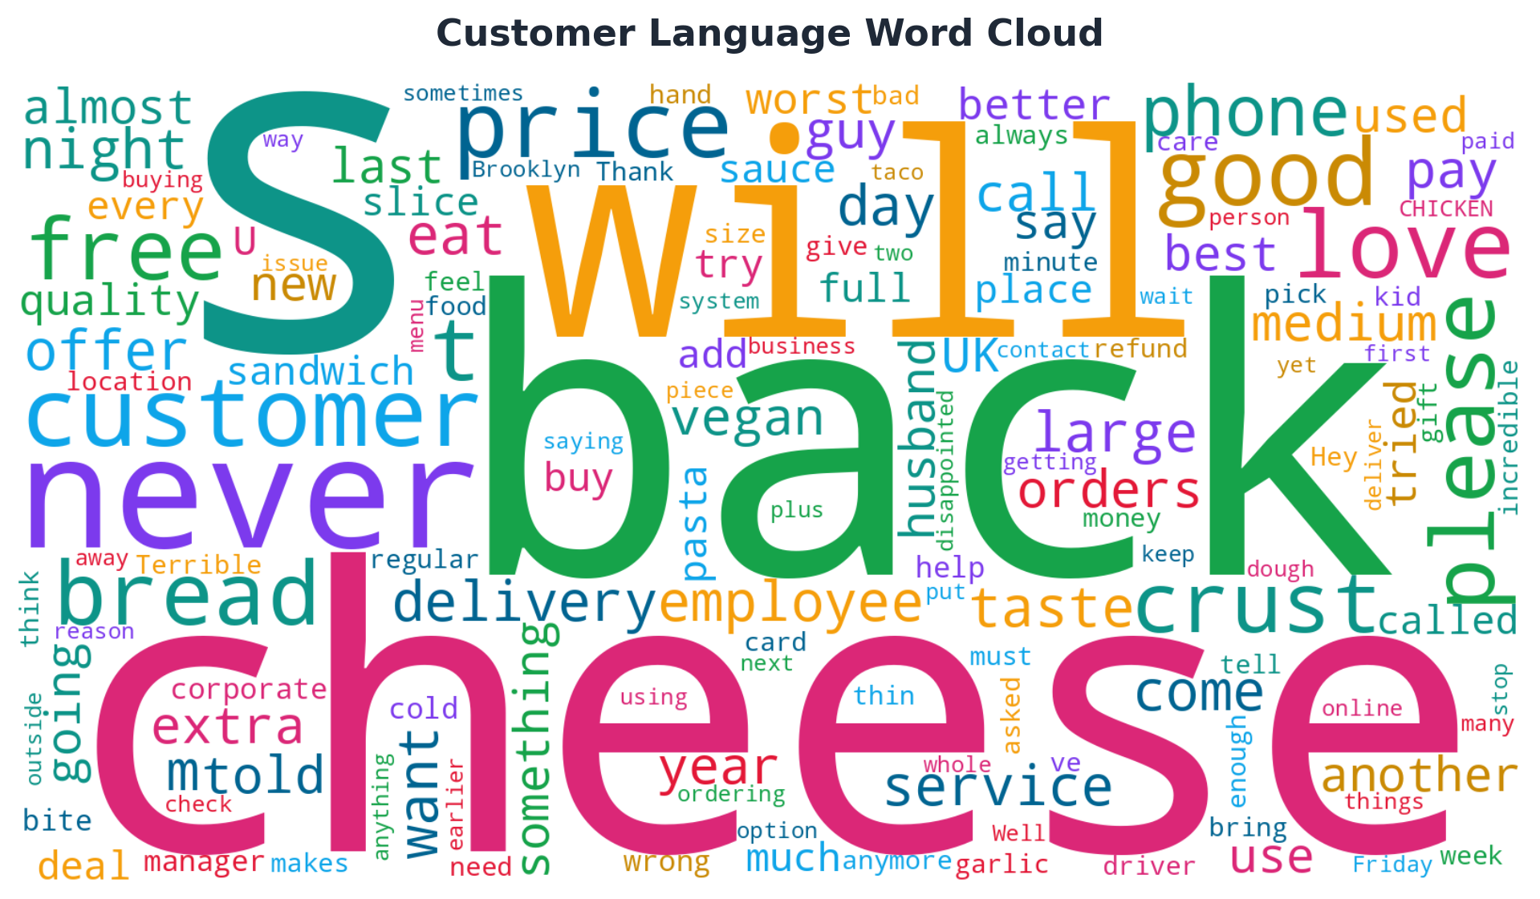
Figure 9. Word cloud of customer language after removing the brand name and common generic terms.
The word cloud reinforces the central themes: cheese, bread, crust, price, free offers, phone contact, delivery, service, vegan demand, menu return requests and quality concerns. Word clouds show prominence, not sentiment by themselves; interpretation must be linked back to coded comments.
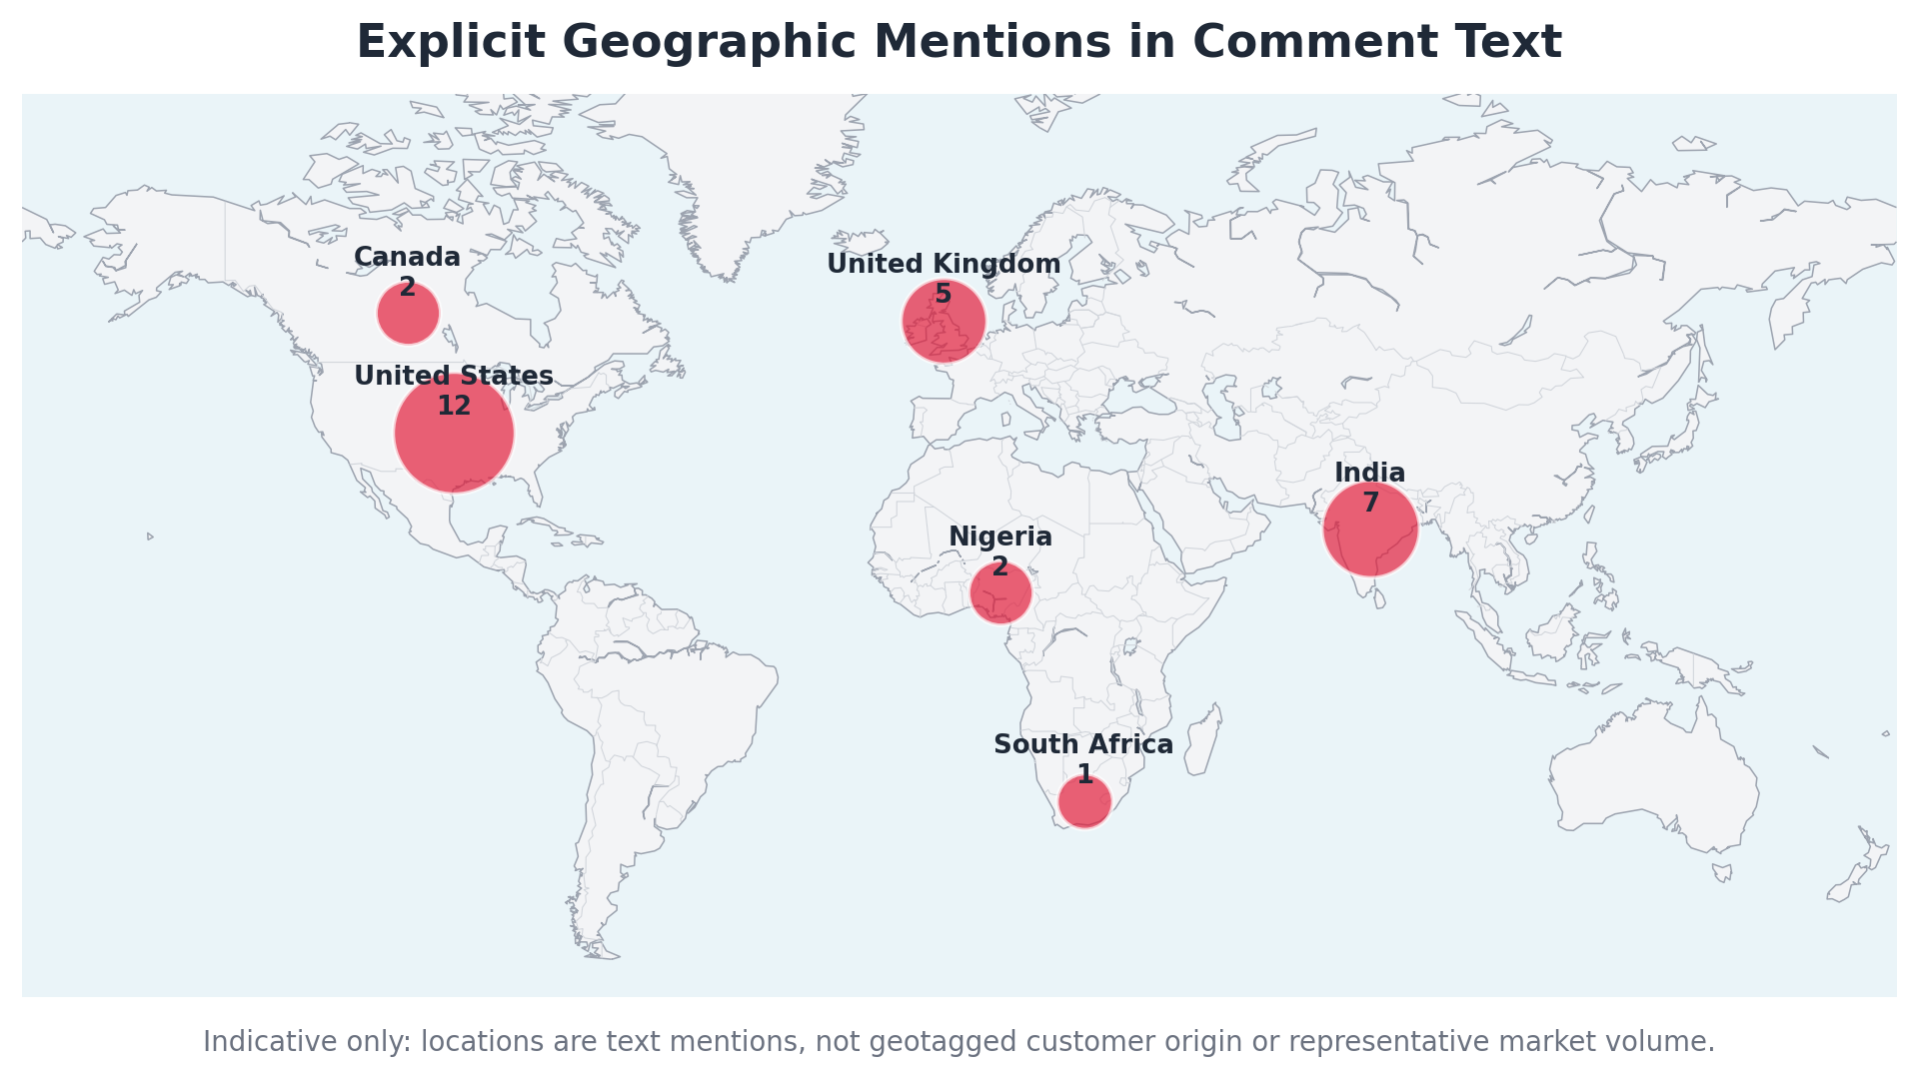
Figure 10. Country-level aggregation of explicit location mentions. This is not a market-volume heat map.
Twenty-eight comments include explicit location entities across six country groupings. The map demonstrates the geographic breadth of the sample, but the locations are neither geotagged nor proportionally sampled. Store-level claims should be investigated individually rather than generalised to the entire country.
Visual analytics index
Figure | Visual | Report Section
Figure 1 | Sentiment mix by platform | Dataset Overview
Figure 2 | Overall sentiment distribution | Overall Sentiment
Figure 3 | Sentiment trend by year | Trend Over Time
Figure 4 | Emotion distribution | Emotion Analysis
Figure 5 | Aspect-based sentiment | Aspect Analysis
Figure 6 | Topic frequency | Topic Analysis
Figure 7 | Complaint categories | Complaint Analysis
Figure 8 | Praise categories | Praise Analysis
Figure 9 | Word cloud | Visualizations
Figure 10 | Geographic mentions | Visualizations

16. Actionable Recommendations
Prioritised roadmap for Customer Experience, Operations, Digital, Marketing and Executive leadership.
Immediate priorities: 0-30 days
Priority | Action | Owner | Success Measure
1 | Create a high-risk complaint escalation protocol | CX, Legal/Compliance, Franchise Ops | Safety, illness, threats, discrimination, accessibility and harassment allegations acknowledged within 2 hours and assigned to an accountable owner.
2 | Implement a service-recovery SLA | Customer Experience | Public complaints acknowledged within 4 hours; refund/remake cases resolved or formally updated within 48 hours.
3 | Audit named and high-risk stores | Operations / Franchise Management | Review food safety, accessibility, driver conduct, staffing and order-quality controls for flagged locations and similar high-complaint stores.
4 | Launch a 30-day fulfilment quality sprint | Operations | Measure order-ready accuracy, late orders, wrong/missing items, cold-food reports, topping compliance and portion-size variance.
5 | Establish digital incident monitoring | Digital Product / Engineering | Track app payment failures, tracker-state mismatches, reward-credit failures and promotion-link problems daily.
6 | Create a social response command centre | Marketing + CX | Use one taxonomy, one case ID and one owner across Facebook, Instagram and X/Twitter so customers are not repeatedly asked for details without resolution.
Medium-term priorities: 1-6 months
Priority | Action | Owner | Success Measure
1 | Standardise product execution | Operations / Quality | Calibrated portion tools, topping guides, bake standards, cut/presentation checks and photo-based exception review.
2 | Redesign service recovery | CX / Finance / Operations | Automated case routing, refund status visibility, closure confirmation and root-cause coding.
3 | Improve ETA and tracker integrity | Digital / Delivery Operations | Use actual store capacity and preparation events; stop displaying employee or readiness states that are not operationally true.
4 | Simplify price and promotion communication | Commercial / Marketing | Clarify base price, collection vs delivery deals, upgrade charges, stacking rules, fees and taxes before checkout.
5 | Train staff and drivers | People / Franchise Operations | Mandatory modules on de-escalation, phone etiquette, accessibility, service animals, hygiene, safe driving and complaint ownership.
6 | Pilot vegan cheese and menu returns | Product / Marketing | Test vegan cheese plus one or two nostalgia items in selected markets with incremental sales and repeat-purchase measurement.
7 | Create channel-specific advocacy programmes | Marketing | Amplify YouTube/TikTok product fans while using Facebook/Instagram for visible recovery proof and operational accountability.
Long-term priorities: 6-12 months
Priority | Action | Owner | Success Measure
1 | Build a unified Voice-of-Customer platform | Executive, Data, CX | Continuous social, complaint, app, survey and transaction feedback linked to stores, products and root causes.
2 | Introduce franchise/store experience scorecards | Operations / Franchise Leadership | Monthly quality, delivery, digital, complaint and recovery metrics with coaching and accountability.
3 | Develop predictive fulfilment and dispatch | Digital / Data / Delivery | Capacity-aware promises, proactive delay alerts and improved route/address validation.
4 | Create an evidence-led menu innovation pipeline | Product / Insights | Regular tests for localised flavours, dietary inclusion, discontinued-item returns and customisation demand.
5 | Rebuild trust through proof, not slogans | Brand / Corporate Affairs | Publish measurable improvements in delivery accuracy, complaint closure, product consistency and accessibility.
6 | Establish a representative benchmark programme | Insights / Strategy | Expand to a stratified multi-market dataset with random sampling, competitor reviews, engagement weighting and recurring tracking.
Executive KPI dashboard
Management Area | Recommended KPIs
Customer recovery | Complaint acknowledgement time; resolution time; refund ageing; reopened cases
Fulfilment | On-time ready rate; on-time delivery; wrong/missing item rate; cancellation rate
Product consistency | Portion variance; topping compliance; remake rate; cold/burnt/quality complaints
Digital experience | Checkout success; payment failure; tracker accuracy; rewards-credit success
People and safety | Escalated conduct cases; accessibility compliance; hygiene audit scores; driver incidents
Brand health | Net sentiment; positive advocacy; churn intent; competitor-switch mentions; loyalty retention
EXPECTED BUSINESS IMPACT
If implemented well, the programme should reduce repeat complaints, refunds and avoidable churn; improve order accuracy and delivery confidence; increase conversion from promotions; strengthen loyalty; and create more consistent franchise-level execution. Numeric impact should be forecast only after baseline KPIs are established.

17. Conclusion
Conclusion Area | Assessment
Overall customer perception | Domino's is a well-known, craveable and emotionally salient brand, but the sampled experience is dominated by inconsistency and weak recovery.
Key emotional drivers | Positive: joy, excitement, love, hope and loyalty. Negative: disappointment, frustration, anger, impatience and disgust.
Major operational strengths | Distinctive taste and menu favourites, strong cravings, brand familiarity, customisation and perceived value when deals work.
Critical weaknesses | Food consistency, customer service recovery, waiting and delivery reliability, order accuracy, staff conduct, digital failures, price-value clarity, hygiene and accessibility.
Strategic priorities | Stabilise execution, close complaints quickly, improve digital truthfulness, enforce people and safety standards, simplify value communication, and test high-demand menu opportunities.
Expected business impact | Higher trust and repeat purchase, lower churn and refund leakage, more effective marketing, stronger franchise consistency and improved brand advocacy.
The central conclusion is that Domino's has meaningful customer love to work with. Customers are still excited by products, still request new and returning items, and still compare the brand favourably with competitors. However, this equity is being spent whenever the operational experience contradicts the brand promise.
The most effective strategy is therefore not simply more promotion. It is disciplined alignment: the food shown in marketing should match the food in the box; the tracker should match store reality; the promised deal should match the final price; and a complaint should produce visible ownership and resolution.
FINAL EXECUTIVE MESSAGE
Protect the craving. Standardise the experience. Recover failures fast. Prove improvement with data.

APPENDIX A - CODING DEFINITIONS
Code | Definition
Positive | Clear praise, affection, satisfaction, favourable recommendation or purchase intent.
Negative | Clear complaint, criticism, anger, rejection, poor experience or churn intention.
Neutral | Information, humour, a question or brand mention without clear evaluative direction.
Mixed | Substantive positive and negative evaluation in one comment.
Emotion coding | Multi-label assessment of expressed or strongly implied emotional state.
Aspect coding | Multi-label business area mentioned in the comment; aspect polarity can differ from overall polarity.
Complaint / praise coding | Multi-label operational categories used to identify root-cause and delight themes.
Sentiment colour legend
Positive | Negative | Neutral | Mixed
APPENDIX B - DATA AUDIT TRAIL
The accompanying Excel workbook contains the cleaned and classified record-level dataset, reconstructed dates, precision flags, overall sentiment, emotion labels, aspects, aspect-level sentiment, complaints and praise tags. It is intended to support review, classroom discussion and reproducibility.
Audit Item | Value
Supporting workbook | dominos-sentiment-analysis-workbook.xlsx
Raw source workbook | raw-comments.xlsx
Analytical denominator | 129 usable comments
Excluded item | ID 99 - no comment text
Date anchor | 21 July 2026 at 20:00 WAT
Classification approach | Human-reviewed structured coding with transparent category definitions
RECOMMENDED NEXT STUDY
Collect a larger stratified sample by market, platform, post type and month; include engagement metrics, verified transaction linkage where possible, and a competitor sample. Use the present taxonomy as the coding framework for the expanded study.

